- In Cisco Packet Tracer, set up a simple network with a router, one internal PC, and one external PC. Assign private IP addresses to the internal PC and public IP addresses to the external PC, then configure static NAT on the router to allow the internal PC to communicate with the external PC.
Answer
Configure Static NAT
Objective: Connect an internal PC with a private IP address to an external PC with a public IP address using Static NAT.
Network topology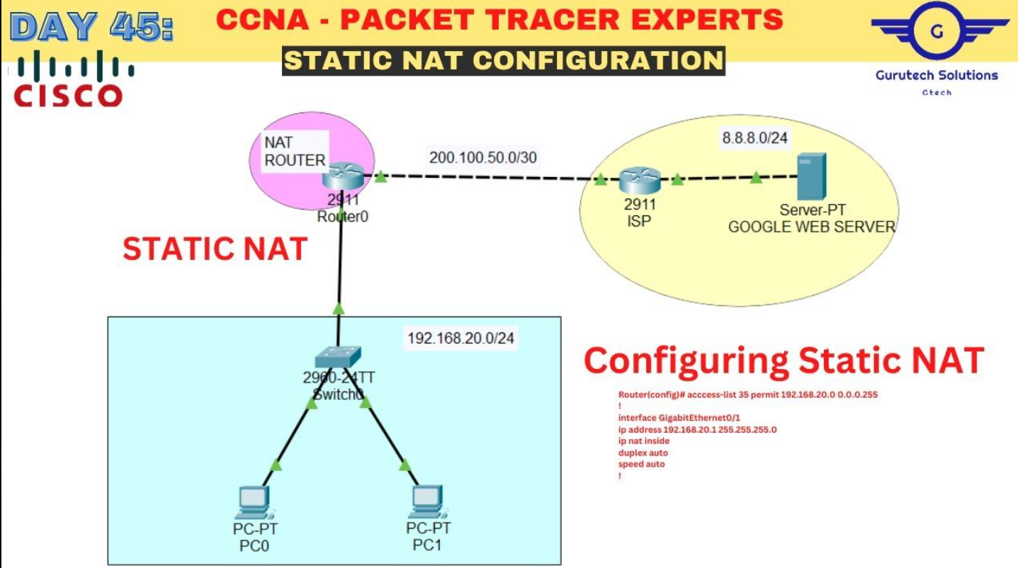
- YouTube
youtube.com
IP addressing table
Device | Interface | IP address
Internal PC | NIC | 192.168.1.10
Router | G0/0 | 192.168.1.1
Router | G0/1 | 203.0.113.1
External PC | NIC | 203.0.113.10
Static NAT mapping:
- Private IP: 192.168.1.10
- Public IP: 203.0.113.2
Router configuration
enable
configure terminal

interface gigabitEthernet 0/0
ip address 192.168.1.1 255.255.255.0
ip nat inside
no shutdown
exit

interface gigabitEthernet 0/1
ip address 203.0.113.1 255.255.255.0
ip nat outside
no shutdown
exit

ip nat inside source static 192.168.1.10 203.0.113.2

end
write
PC configuration:
- Internal PC IP: 192.168.1.10
- Subnet mask: 255.255.255.0
- Default gateway: 192.168.1.1
- External PC IP: 203.0.113.10
- Subnet mask: 255.255.255.0
- Default gateway: 203.0.113.1
Result: The router translates the internal PC's private IP into the mapped public IP 203.0.113.2.
Note: These public addresses are documentation/test addresses for the Packet Tracer lab, not real Internet-routable addresses.

- Configure Port Address Translation (PAT) on a router in Packet Tracer so that two internal PCs with private IPs can access a simulated public web server using a single public IP address.<br><br><em><strong>Hint:</strong> Use the 'ip nat inside source list' command with 'overload' to enable PAT.</em>
Answer
Configure PAT (Port Address Translation)
Objective: Allow two internal PCs to access one external web server using a single public IP address.
Network topology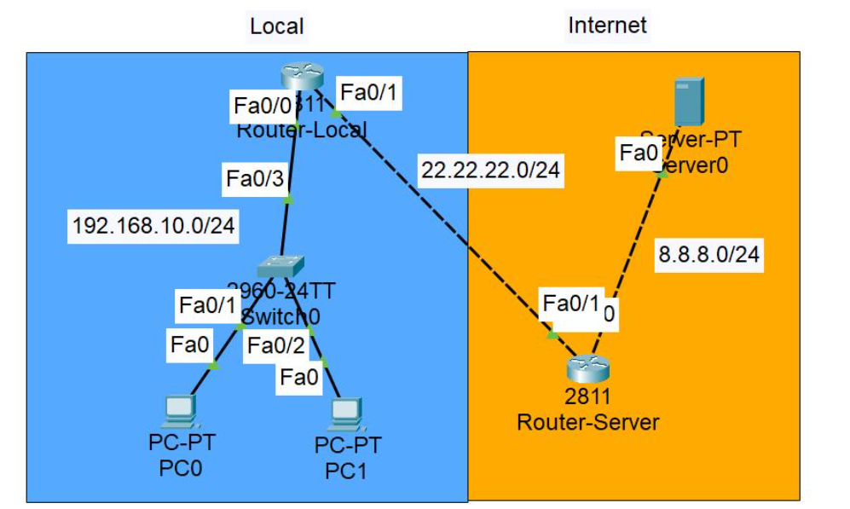
Cisco : Dynamic NAT Overload. Dynamic Nat Overload adalah konfigurasi… | by Muhammad Ilham Harits | Medium
medium.com
IP addressing table
Device | IP address
PC1 | 192.168.1.10
PC2 | 192.168.1.20
Router LAN | 192.168.1.1
Router WAN | 203.0.113.1
Web Server | 203.0.113.10
Router configuration
enable
configure terminal

interface gigabitEthernet 0/0
ip address 192.168.1.1 255.255.255.0
ip nat inside
no shutdown
exit

interface gigabitEthernet 0/1
ip address 203.0.113.1 255.255.255.0
ip nat outside
no shutdown
exit

access-list 1 permit 192.168.1.0 0.0.0.255

ip nat inside source list 1 interface gigabitEthernet 0/1 overload

end
write
PC default gateway: 192.168.1.1
Web server default gateway: 203.0.113.1
Explanation: The overload command allows multiple private IP addresses to share one public IP address by using different port numbers.

- Test your NAT configuration by sending a ping from the internal PC to the external PC and capture the NAT translation table on the router to verify the address mapping.
Answer
Add a Third Internal PC
Objective: Modify the network so three internal PCs can access the external network using PAT.
Updated network topology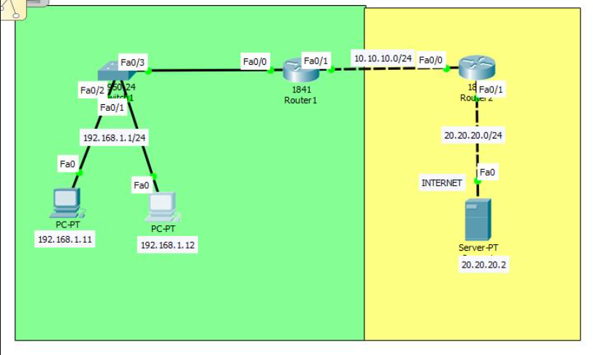
Konfigurasi Overload NAT(PAT) di Cisco Packet Tracer
annisapuspa61.blogspot.com
Updated IP addressing table
Device | IP address
PC1 | 192.168.1.10
PC2 | 192.168.1.20
PC3 | 192.168.1.30
Router LAN | 192.168.1.1
Router WAN | 203.0.113.1
Web Server | 203.0.113.10
Configuration
The existing PAT configuration already permits the entire 192.168.1.0/24 network.
Therefore, no new NAT command is required.
Configure PC3:
- IP address: 192.168.1.30
- Subnet mask: 255.255.255.0
- Default gateway: 192.168.1.1
Test all three PCs
From each PC, open Command Prompt and enter:
ping 203.0.113.10
All three PCs should receive successful ping replies.
Verify the NAT table
On the router:
show ip nat translations
You should see entries for all three internal PCs sharing the public IP 203.0.113.1.
Inside Local Inside Global
192.168.1.10 203.0.113.1
192.168.1.20 203.0.113.1
192.168.1.30 203.0.113.1
Simplified illustration; actual output also displays protocol and port information for PAT.
Expected result
All three PCs can access the external web server using one public IP address.

4.
Modify your Packet Tracer topology to add a third internal PC. Update your NAT or PAT configuration so all three internal PCs can access the external network, and verify that each translation appears in the router's NAT table.
Answer
Test NAT Configuration
Objective: Verify that NAT is working correctly using ping commands and the router's NAT translation table.
Step 1: Test connectivity
Open Internal PC → Desktop → Command Prompt.
Enter:
ping 203.0.113.10
If successful, the internal PC can communicate with the external PC.
Step 2: Check NAT translation table
Open the router CLI and enter:
enable
show ip nat translations
For Static NAT, you should see a mapping similar to:
Inside local | Inside global
192.168.1.10 | 203.0.113.2
For PAT, you should see dynamic entries similar to:
Inside local | Inside global
192.168.1.10:1025 | 203.0.113.1:1025
192.168.1.20:1026 | 203.0.113.1:1026
Example entries only; actual port numbers may differ.
Step 3: Check NAT statistics
show ip nat statistics
This command displays NAT statistics and translation information.
Expected result
NAT translations should appear when communication takes place. Static NAT mappings normally appear even before traffic is sent.

5.Explain in your own words how NAT and PAT help apps like Zomato or Flipkart serve millions of users with limited public IP addresses. Give two real-world scenarios where incorrect NAT/PAT setup could break connectivity for users.
Answer
Real-world applications of NAT and PAT
How NAT and PAT help Zomato and Flipkart
Apps like Zomato and Flipkart serve millions of users every day.
NAT and PAT help networks conserve public IPv4 addresses.
Example:
- Millions of users connect to the Internet through private IP addresses.
- NAT translates private IP addresses into public IP addresses.
- PAT allows multiple devices to share one public IP address using different port numbers.
- This reduces the requirement for unique public IPv4 addresses for every device.
Two real-world scenarios of incorrect NAT/PAT configuration
Scenario 1: Incorrect NAT configuration
A company configures the wrong private-to-public IP mapping on its router.
- Employees cannot access external websites or services.
- Applications may fail to connect to their servers.
- Network communication gets interrupted.
Scenario 2: Incorrect PAT configuration
A company forgets to configure the overload command.
- Multiple internal computers may not share the same public IP properly.
- Users may experience Internet connectivity problems.
- Applications such as Zomato and Flipkart may fail to load correctly from that network.
Important NAT and PAT commands for practical exams
Command | Purpose
ip nat inside | Identifies the internal interface
ip nat outside | Identifies the external interface
ip nat inside source static | Configures Static NAT
access-list 1 permit | Allows internal IP addresses
ip nat inside source list 1 interface g0/1 overload | Configures PAT
show ip nat translations | Displays NAT translations
show ip nat statistics | Displays NAT statistics
clear ip nat translation * | Clears dynamic NAT translations
Conclusion
NAT translates private IP addresses into public IP addresses, while PAT allows multiple devices to share a single public IP address using different port numbers. Both technologies help conserve IPv4 addresses and provide Internet connectivity to multiple users.

